**DOWNLOAD MOTION LIBRARY**

In order to download the Motion Library plug-in for Unity users must visit the [following link](https://assetstore.unity.com/motion-library) or search “Motion Library” through the in-editor version of Unity’s Asset Store.

**IMPORT MOTION LIBRARY**

Upon clicking download, an import window will appear. Click ‘Import” to import Motion Library into your project.

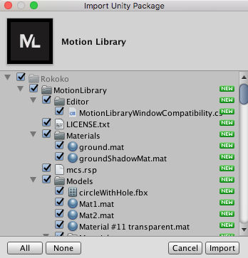

**ACCESS MOTION LIBRARY**

After importing the plug-in, access Motion Library by clicking Window > Motion Library.

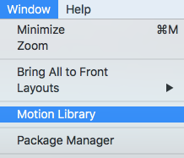

The Motion Library window will appear. If you have .NET 4.x enabled you should be able to access the Motion Library and view the selection of animations!

**ENABLE .NET 4.X**

If you do not have .NET 4.x enabled, the following prompt will appear and you will need to click “Please, change setting and close Unity.

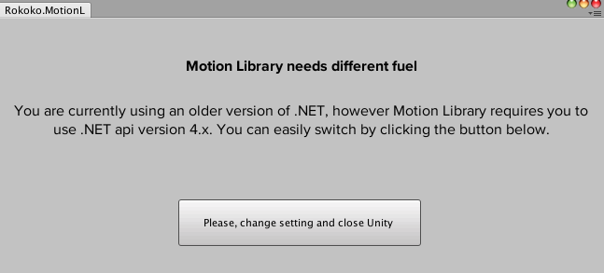

Clicking the button will enable .NET 4.x, and immediately close your Unity client. You will then need to re-open the same exact Unity project for the settings to have taken effect, otherwise creating a new project will keep your old settings.

Once you reopen Motion Library, you should be able to access the Motion Library!

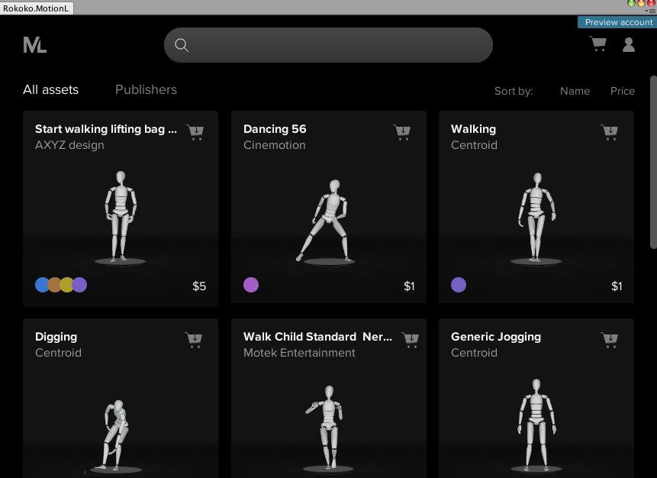

**SUPPORT**

If you have any issues or questions about the Motion Library plug-in, please contact us through our support channels so that we can assist you.

Support Email: support@rokoko.com

Support Tickets: [Click Here](https://rokoko.atlassian.net/servicedesk/customer/portal/4/group/5/create/22)

Report Bugs: [Click Here](https://rokoko.atlassian.net/servicedesk/customer/portal/4/group/5/create/26)​

Forum:[Click Here](https://forum.unity.com/threads/released-rokokos-motion-library.566497/)